

Peripheral & Interfacing Lab(CSE 316)

Mid project

Documentation/ Lab Report

|  |  |
| --- | --- |
| Submitted by | Submitted to |
| Niamul Hasan  Id: **17201026**  Semester: 3.2  Section: A1 | Abdullah Al Omar  Lecturer  Department of CSE  UAP |

**Project Name: Party light**

**Introduction:**

This project is just about, lighting up the LEDs of different colors in different way and in different techniques.

Proteus contains [LEDs](https://en.wikipedia.org/wiki/Light-emitting_diode) of different colors and types that are being used in real time applications.  
LEDs are found in Proteus software under Library category Optoelectronics. Remember to use ‘ACTIVE’ components so that the simulator provides real time interface during simulation.

**Equipment for the projects:**

1. Arduino UNO
2. LEDs (12 piece)
3. Switch (2 piece)
4. Resistor (POT 14 piece)
5. VCC-Power source(2 piece)
6. GND-Ground(3 piece)

**Motivation:**

To learn try to do better coding in the Arduino. This project is mainly focused on coding part and on coding logics.  
So, by doing this project, I preferred to learn; how to apply logic on Arduino environment.  
Besides that, learn how to use the Arduino board as micro-controller board.   
Analyze, the working procedure of party lights.

**Circuit diagram:**

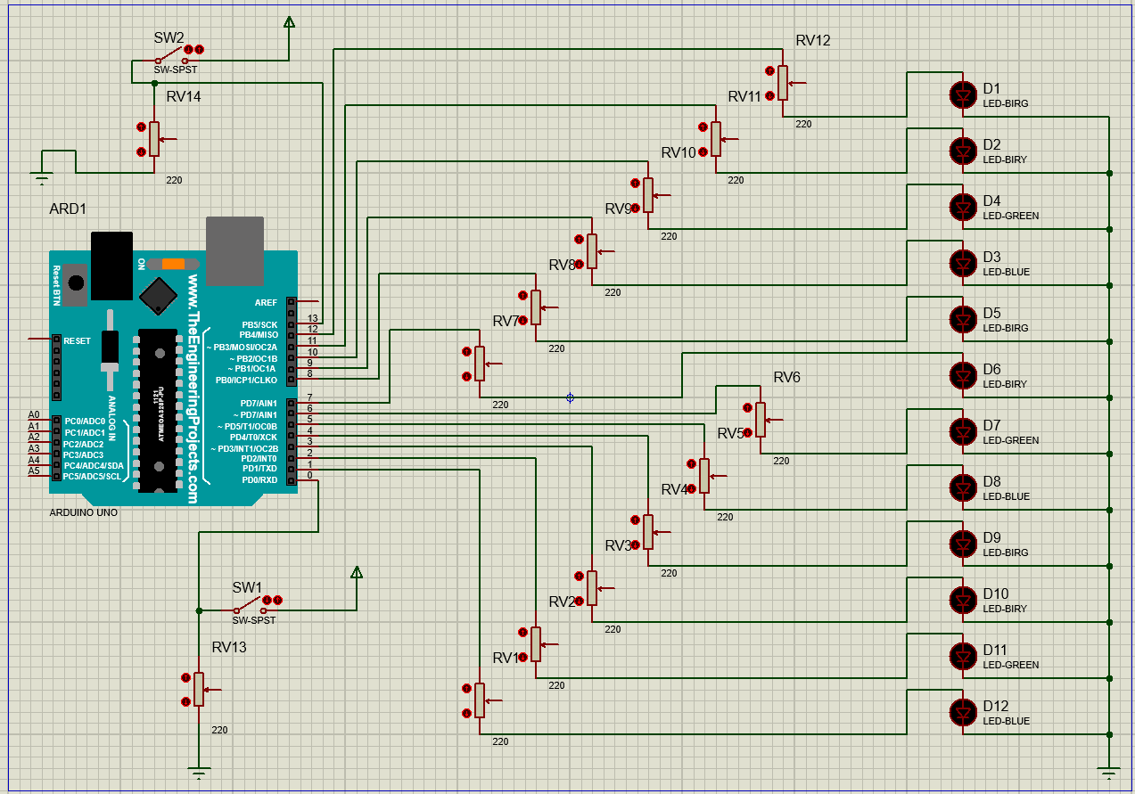

Here in the circuit diagram, we can see 2 switches.

LEDs

One is system switch and another one is LED’s functionality change switch.

At top left corner, is the power switch. At bottom left corner, is the functionality change switch.  
At left side of the circuit diagram, we see 12 LEDs of different colors.

**Functionality:**

Here total 2 types of functionalities will be shown.

Functionality 1 (up-down functionality):

When both switches are ON, then this up-down functionality will be working.  
where first LED from bottom will power ON then 2nd from bottom. like this it will power ON all the LEDs to top. then it will start power off from top to bottom.  
now it will power on the LEDs from top to bottom and power off from bottom to up.

Functionality 2:

Where Power switch is ON and Functionality change switch is OFF, this functionality will be working.  
Here, multiple LED functionality will be shown.

**Code With documentation (comments):**

void serially(); //function prototype

void lightUp(); //function prototype

void lightDown(); //function prototype

void blink_blink();//function prototype

void allFunc();//function prototype

void upDownFunc();//function prototype

void turnOffAll();//function prototype

void setup() { //void setup start

pinMode(13, INPUT); // pin 13 for input

pinMode(12, OUTPUT);// pin 12 for input

pinMode(11, OUTPUT);// pin 11 for input

pinMode(10, OUTPUT);// pin 10 for input

pinMode(9, OUTPUT);// pin 9 for input

pinMode(8, OUTPUT);// pin 8 for input

pinMode(7, OUTPUT);// pin 7 for input

pinMode(6, OUTPUT);// pin 6 for input

pinMode(5, OUTPUT);// pin 5 for input

pinMode(4, OUTPUT);// pin 4 for input

pinMode(3, OUTPUT);// pin 3 for input

pinMode(2, OUTPUT);// pin 2 for input

pinMode(1, OUTPUT);// pin 1 for input

pinMode(0, INPUT);// pin 0 for input

} //void setup end

void loop() { //void loop start

int Switch = digitalRead(13); // system switch input

int Func = digitalRead(0); // functionallity changing switch

if (Switch == HIGH) { // if system switch ON

if (Func == HIGH) { //if functionallity changing switch is ON, show up/down lighting functionality

upDownFunc(); // calling function to show a lighting functionality

}

else {// else, show 2nd lighting functionality

allFunc(); // calling function to show a lighting functionality

}

}

else { // if system switch Off

turnOffAll();

}

} //void loop end

void allFunc() { //allFunc start

blink_blink();

lightUp();

lightDown();

blink_blink();

serially();

blink_blink();

} //allFunc end

void upDownFunc() { //upDownFunc start

lightUp();

lightDown();

} //upDownFunc end

void blink_blink() {

delay(200);

for (int i = 0; i < 2; i++) {

digitalWrite(12, HIGH);

digitalWrite(11, HIGH);

digitalWrite(10, HIGH);

digitalWrite(9, HIGH);

digitalWrite(8, HIGH);

digitalWrite(7, HIGH);

digitalWrite(6, HIGH);

digitalWrite(5, HIGH);

digitalWrite(4, HIGH);

digitalWrite(3, HIGH);

digitalWrite(2, HIGH);

digitalWrite(1, HIGH);

delay(200);

digitalWrite(12, LOW);

digitalWrite(11, LOW);

digitalWrite(10, LOW);

digitalWrite(9, LOW);

digitalWrite(8, LOW);

digitalWrite(7, LOW);

digitalWrite(6, LOW);

digitalWrite(5, LOW);

digitalWrite(4, LOW);

digitalWrite(3, LOW);

digitalWrite(2, LOW);

digitalWrite(1, LOW);

delay(200);

}

delay(200);

}

void lightUp() {

for (int i = 1; i < 13; i++)

{

digitalWrite(i, HIGH);

delay(100);

}

for (int i = 12; i > 0; i--)

{

digitalWrite(i, LOW);

delay(100);

}

}

void lightDown() {

for (int i = 12; i > 0; i--)

{

digitalWrite(i, HIGH);

delay(100);

}

for (int i = 1; i < 13; i++)

{

digitalWrite(i, LOW);

delay(100);

}

}

void serially() {

delay(120);

for (int i = 1 ; i < 13; i++)

{

digitalWrite(i, HIGH);

digitalWrite(13 - i, HIGH);

delay(150);

digitalWrite(i, LOW);

digitalWrite(13 - i, LOW);

}

delay(120);

}

void turnOffAll() {

digitalWrite(12, LOW);

digitalWrite(11, LOW);

digitalWrite(10, LOW);

digitalWrite(9, LOW);

digitalWrite(8, LOW);

digitalWrite(7, LOW);

digitalWrite(6, LOW);

digitalWrite(5, LOW);

digitalWrite(4, LOW);

digitalWrite(3, LOW);

digitalWrite(2, LOW);

digitalWrite(1, LOW);

}

// end of code

**Conclusion:**

So, by doing this project, I learned how to apply logic on Arduino environment.  
Besides that, learned how to use the Arduino board as micro-controller board.   
Analyzed, the working procedure of party lights.